https://academics.maine.edu/early-college/

Homeschool Application Guidelines

The student will initiate the application
Visit https://academics.maine.edu/early-college/explorec-portal/ for general information, frequently asked questions, and student directions to begin the application process.

The student will submit the application
After the student submits the application, the parent will receive an email sign-off, and a link to the Parent Consent Form.

Parent Consent Form/Recommendation form

There are two tabs. Both are required.

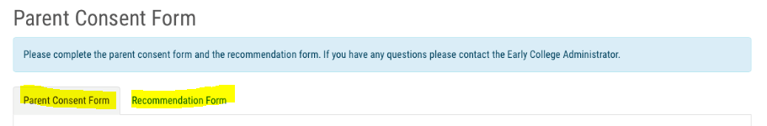
The Parent Consent Form tab acknowledges FERPA limitations, credit limitations, and fee responsibility. The Recommendation Form is what the school counselor would normally see, so the parent will be performing this role. Some fields will be redundant or not seem applicable (e.g. “The students parent/guardian has been informed” and “the student has permission of the high school”). Please enter yes in these fields. Student GPA can be estimated. The only required fields in the recommendation section are highlighted below. Note that transcripts, standardized test scores, and other documentation are not required unless the EC Administrator requests them.

Student state ID:
Enter a random, unique 9 digit number that starts with 9. Please DO NOT enter 999999999.
This is necessary in order for the automated part of the system to recognize the student as homeschooled, and automatically create a unique University ID in the University Registration system (MaineStreet). This process has been approved by the DOE and will not affect the free tuition opportunity.

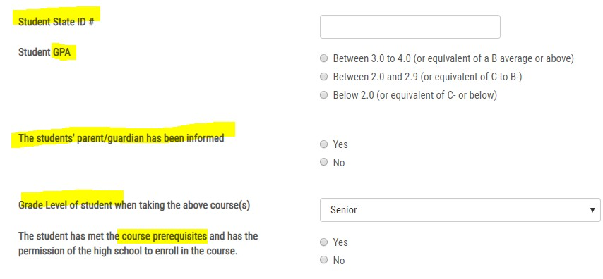

Upload Documents (optional)
If additional documentation is needed (e.g. to demonstrate prerequisites have been met) or information is requested, use the upload feature and description field to provide information to help the EC Administrator make a final decision about the student application. If no information is needed, you can “submit recommendation” and leave these fields blank. Parents will use the same email link to return to this page if additional information is required after the application has been submitted.
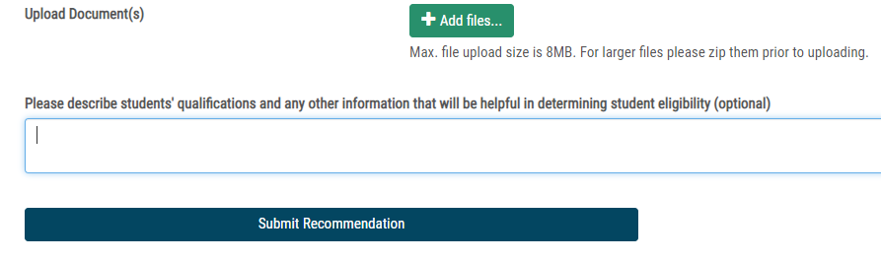

After you submit the recommendation you will receive a success message. You can verify that the process is moving forward by having the student log in to their account. If the course status is “Approved” then the application will move forward to the EC Administrator and the student to be enrolled with the University in MaineStreet. The student/parents will be notified when the student is registered for the course or if any further documentation is necessary.

Please contact amy.l.hubbard@maine.edu if you have any questions or issues with ExplorEC.
For questions about specific courses and prerequisites, please contact the Early College Administrator at the University.
https://academics.maine.edu/early-college/early-college-contact-us/

