ExplorEC:

Directions for High School Guidance Counselor or Administrator

Guidelines for High School Guidance Counselors or High School Administrator who will review and approve student applications.

Log in at:
https://explorec.maine.edu/

Select Guidance Counselor or Administrator. Note that this portal will be used for all students wishing to take classes at any of Maine’s Public Universities.
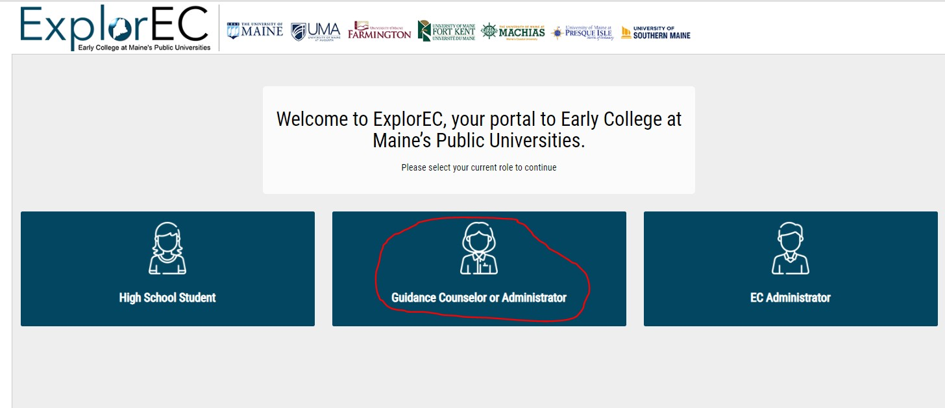

Applications
Click on Applications to review and approve current applicants. The number represents how many applications need your attention.

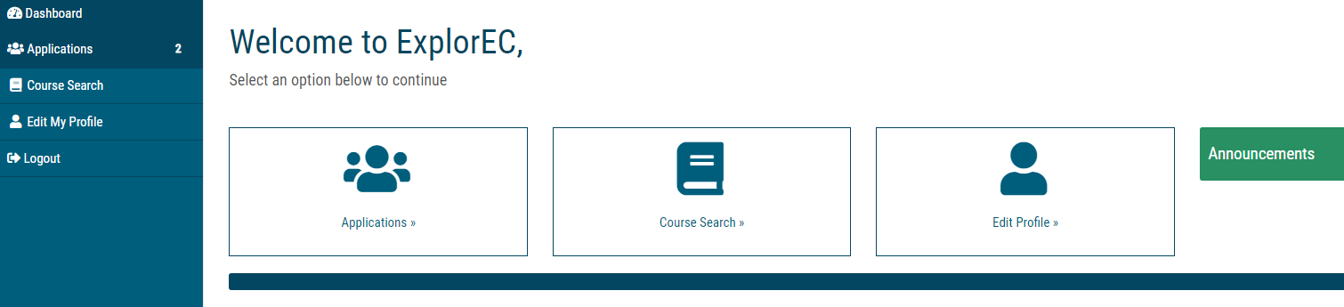

A summary of pending applications is shown.

Review and approve student applications
Click on Manage Details to review and approve each student.

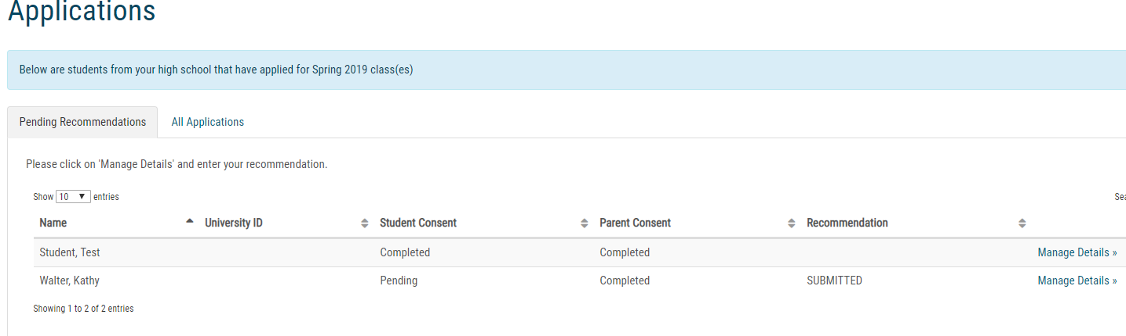
The student and parent names will be pre-populated by the student. The courses the student is applying for will appear on the right. Please note that registration is not finalized until the EC administrator at the University enrolls the student, so the courses that appear are applications only, and are pending approval and final registration.

Required fields
The only required fields in the recommendation section are highlighted. Note that transcripts, standardized test scores, and other documentation are not required unless the EC Administrator requests them.
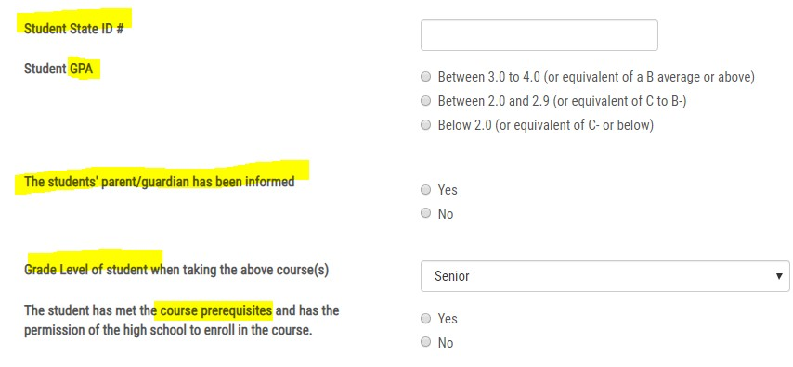

Notes
The notes field will generate an email to the EC Administrator about the student. The EC Administrator will use this field if additional information about the student is needed.

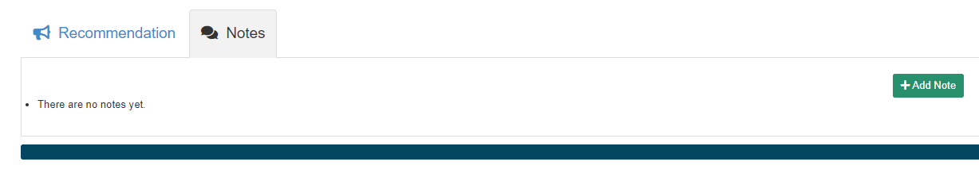

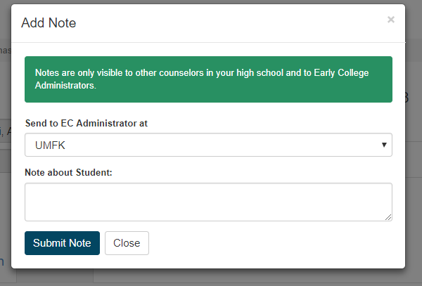

Upload Documents (optional)
If additional documentation or information is requested, use the upload feature and description field to provide information to help the EC Administrator make a final decision about the student application. If no information is requested, you can “submit recommendation” and leave these fields blank.
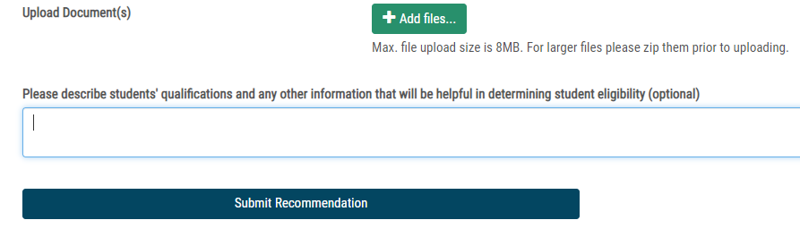

After you submit the recommendation you will receive a success message.

All Applications Tab
The All Applications tab will show all of the applications for your high school and their status in the process.
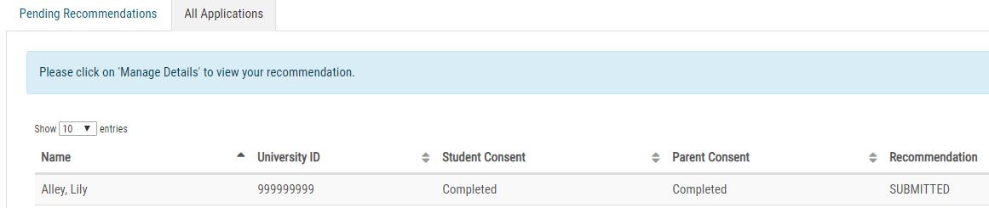

Dashboard
Note that 3 applications still need high school counselor or administrator review, and this number shows up in the dashboard.

