Early College 2020 Report
Updated 2-17-21

Authors:
Amy Hubbard
Amy.l.hubbard@maine.edu
Executive Director of Early College, University of Maine System
https://www.maine.edu/students/early-college/

Justin Young
Bob Zuercher
Haliru Omosun

UMS Office of Institutional Research

The Early College programs at Maine’s Public Universities are a critical resource for Maine’s high school students state-wide. Students benefit from expanded curriculum offerings, particularly in rural schools or in content areas where there are teacher shortages. Student outcomes include high course success rate, confidence in their ability to complete college level work, increased college aspirations, higher GPA’s and persistence rates, and higher college graduation rates. While all students who take a UMS EC course benefit, underserved students benefit most.

Definitions and Course Modality

Early College (EC) is an umbrella term that refers to any program in which high school students earn college credit while still in high school. The term dual enrollment is also widely used nationally and in Maine because it reflects the high school student’s experiences and outcomes as they are enrolled in high school and college simultaneously. There are three primary course modalities at Maine’s Public Universities: on campus(or at a campus center), online, or concurrent enrollment (CE), which include courses taught at the student’s high school. CE courses are taught by college-approved high school teachers in collaboration with university faculty. CE courses include Bridge Academy, which adds college level courses to Career and Technical Education programming.

Introduction

EC programs within the University of Maine System (UMS) have experienced significant growth recently due to commitment from system and university leaders, State support, and collaboration with the Department of Education. Maine’s Public Universities already served their local communities, and many provided statewide outreach. However, each program operated independently. System-driven growth has been strategic, with a focus on equity. Equity in EC means that the students serve reflect the demographic, socioeconomic, and geographic diversity of the K-12 student population (Zinth, 2019). Nationally, equity in EC programs is a concern, “Evidence shows that students, especially those who otherwise might not have a clear path to postsecondary education, are often shortchanged. They never learn about dual enrollment; their parents can’t afford the tuition, fees, or transportation to campus; their K-12 education didn’t prepare them well enough; or they’re excluded altogether from the opportunity” (Mehl, Wyner, Barnett, Fink, & Jenkins, 2020, p. 2). Several program changes were implemented system-wide to avoid these pitfalls. In order to ensure historically underrepresented students realize the full benefits of EC courses, programs must be deliberately designed to close the equity gap (Mehl et al., 2020). The student-centered alignment and collaboration between all seven of Maine’s Public Universities is addressing the equity gap.
Each course modality varies in accessibility to students, which is why programs with a wide variety of modalities are most equitable. On campus courses are least accessible because students need to provide their own transportation and coordinate their high school and college schedules. Online courses are available to students statewide, but students must have access to technology, broadband internet, and be self-motivated and well-prepared for independent work. CE courses are the most accessible, because they are integrated into the student’s normal school day. Courses are often offered over a full year instead of a semester. Students meet the same learning outcomes as the on-campus course, but have the additional time and support of their high school teacher. This can help ease the transition to college level expectations for students that might not be considering college in their future plans. However, CE course offerings are limited because not all high school teachers have the credentials needed for approval by college faculty. More recently, universities have offered a modality referred to as “EC plus”, in which a cohort of students are enrolled in an online course. The course content is delivered by university faculty, but the high school teacher provides classroom support. This model provides access and student support when teachers cannot be approved to teach independently by university faculty, but are willing to serve as a bridge between the university course and their students.

EC Funding

The UMS relies on State-supported funding sources to provide free or low cost EC opportunities to Maine’s high school students. Maine’s public high school students and homeschooled students are eligible to receive up to 12 tuition-free credits per year through the Aspirations program, which is administered by the Department of Education. The 12-credit limit includes courses at both the University of Maine System and Maine’s community colleges combined. Each campus receives approximately half of the in-state tuition rate per credit in reimbursement from Aspirations, while campuses waive the remaining portion and absorb the remaining unfunded cost. UMS has established an EC tuition rate, which is equal to the Aspirations reimbursement, to provide discounted tuition to any student attending high schools in Maine that do not qualify for Aspirations funding. The Aspirations/EC tuition rate for FY21 is $138.25 per credit.
Because of the Maine DOE’s support and that of the Maine Legislature and the Governor, as well as the commitment of UMS to expand early college opportunities, enrollment has exploded over the past five years and has increasingly exceeded the amount appropriated through the Aspirations line in the Department’s budget. The DOE has generously continued to make other Department funding resources available to close that gap and ensure equitable access to eligible students under Title 20-A, Chapter 208-A, including an additional $1.1 million in FY20. While the MCCS is fully reimbursed by Maine DOE for early college credits it awards, in FY20 UMS universities waived the $3,333,967 in tuition costs for early college students not subsidized by the Department and both systems now waive most fees which can otherwise be a barrier to low-income students. It is estimated that UMS will waive about $2.5M in fees for FY21, in addition to the tuition waivers provided.
The COVID-19 pandemic has increased demand for EC offerings, as Maine
high schools look to fill new gaps in student schedules and curriculum created by the need to
offer in-person, hybrid and remote instruction and educators being on family or medical leave.
At the same time, the financial pressures posed by the pandemic means that the DOE has less flexibility than in year’s past to cover overages. UMS, MCCS, and the Maine DOE are working together to draft possible changes to ensure fair, equitable and predictable access for future years.
An operational budget supports system-level and individual campus programming. The Early College Executive Director leads collaborative efforts with all EC programs. EC administrators at each campus recruit students, build relationships with partner high schools, train and assist school counselors, process student applications, provide college advising to students and their families, support students during the semester, and serve as the primary front-line liaisons between the high school and university. Students from 196 high schools in Maine have accessed EC courses at Maine’s Public Universities, which includes every public high school in the state.

Program Context and Goals

Maine’s high school graduation rate of 87% is comparable with the New England average of 88% (2019). College enrollment rates, however, reveal a widening gap. Maine’s college enrollment decreased from 62% in 2011 to 58% in 2018, while the New England rate has increased from 62% to 66% during that same timeframe. Similarly, while college persistence rates have remained stable in some New England states, Maine’s persistence rates have varied from year to year. Maine’s college completion rate is improving. In 2013, Maine’s 6 year completion rate was 50%, compared with 58% in New England (Judd, 2020). For 2019 those numbers increased to 62% for Maine and 65% for New England.
Many students are underprepared when they enter college because the expectations and norms of high school do not translate well to college requirements. A review of national research confirms that quality early college programs address this issue, and are transformative for students (An & Taylor, 2019; Mehl et al., 2020). Students who take early college courses are seven times more likely to matriculate, have higher college GPAs, are more likely to remain in college, and more likely to earn a degree (An & Taylor, 2019).
Since receiving direct funding from the State, in addition to the tuition reimbursement that was already in place, the Early College program at UMS has focused on providing equitable access to high quality programs, raising college aspirations, and ensuring affordability to reduce college debt. EC program growth has emphasized career exploration and Maine’s workforce needs, which aligns with the State’s 10-year economic plan. System and university leaders committed to student-centered, system-wide collaboration and alignment. The first steps involved collectively and systemically eliminating barriers. Barriers to access, particularly in rural areas, include strict admissions requirements, course fees, and transportation to a college campus (Roach, Gamez Vargas, & David, 2015).
Three key changes removed barriers. First, university leaders agreed to an open-access policy for courses without prerequisites that relies on collaboration with, and approval from, the student’s high school counselor. Then, UMS launched ExplorEC, a single, uniform online application that provides students with access to courses at all institutions regardless of their geographic location. Finally, starting in the fall 2020, six campuses eliminated universal fees (the University of Maine at Augusta already had a fee free policy in place). This decision was largely based on the premise that campuses could forego income from fees because of the State funding received. With the exception of course-specific fees and books, Maine’s public high school students have tuition and fee-free access to EC courses statewide.

Student Support, Advising, and Career Exploration Pathways

EC teams at each campus provide direct support to students and their families, as well as help students access campus resources. The UMS EC Program also contracted with the company NetTutor, which provides online tutoring services for hundreds of content areas 24 hours per day/7 day per week. All high school students receive this tutoring service free of charge.
The open access policy further allows UMS students the opportunity to select any course they have met the prerequisites for. While these broad opportunities provide many choices, students can be overwhelmed by the vast array of options. All campuses offer gateway courses, which are highly-transferable, foundational courses such math and English, as well as common general education courses including psychology and sociology. While gateway and general education courses are valuable, the best programs “help students understand the degrees and pathways that match their life goals and may lead to well-paying careers”(Mehl et al., 2020, p. 31).
The University of Maine at Machias led the Early College Career Exploration Pathways initiative, offering certificates in key career areas in Maine such as STEM, business, and education. Most recently, the aquaculture certificate was created in response to local workforce needs and per the request of a high school in Washington County. The University of Maine at Fort Kent and the University of Maine at Augusta also offer EC certificates. Similarly, the University of Maine recently released pathways, which are carefully selected courses that align to programs in a variety of majors. These career exploration pathways and certificates help students select a combination of gateway, general education, and content courses to help give them a jump start towards potential college majors. For students who are unsure of which career areas they are interested in, students can explore a combination of content and general education courses before choosing a potential major or college. Plans are currently in place to pilot a one-credit career exploration course at the University of Maine to serve the dual purposes of career and course selection advising.

Expanded Opportunities and Advising in Collaboration with the Maine Community College System

As joint stewards of the Aspirations program in collaboration with the Department of Education, UMS and MCCS have partnered to ensure consistency and equity in Maine’s public early college programming. Jointly, Maine’s public colleges and universities have built and strengthened student-focused partnerships to support Maine’s high schools. These partnerships have ensured that students benefit from a wide range of curricular offerings, career exploration, and support.

Credits with Purpose

EC leaders acknowledged that students were accessing courses at institutions within UMS and MCCS simultaneously. Given the significant investment from the State, it became clear that there was a need to provide counselors, students, and their families better advising to ensure that students choose courses with intention. In addition, EC programs have a fiduciary responsibility to create systems that avoid funding excess or non-transferable credits.
The credits with purpose project resulted from collaboration between Early College leaders at UMS and MCCS. Three key documents were created: a one-page Credits with Purpose flyer, an Early College Career Exploration Pathways Brochure, and a Pathways Poster. Copies of these documents were mailed to every public high school and Career and Technical Education Center in the state, and downloadable flyers are available on system websites (Pour & Hubbard, 2020). In summary, the documents explain how students should review potential programs of study at their target schools to help ensure transferability, understand how financial aid can be impacted if students do not make satisfactory academic progress, and how performing well in a few select courses can prepare students for college better than poor performance in many courses. The Career Exploration Pathways Brochure uses student-friendly language to first help students select common areas of interest. Then, these interests are aligned with EC courses, possible majors at both MCCS and UMS, and possible careers with 2-year or 4-year degrees in these areas.
While the document represents only a few examples of the many career exploration pathways offered by UMS and MCCS, it is a first step in helping high school stakeholders consider aligning content courses to their EC experiences. The Credits with Purpose initiative was shared with practitioners at the National Alliance for CE Partnerships (NACEP) annual conference, and was well received by over 400 seminar participants.

Unified Online Application Process: ExplorEC/OnCourse for College

The implementation of an online application program has been critical to alignment, growth, and success at all of Maine's Public Universities. Thanks to ExplorEC (developed and administered by the software company Canusia), UMS has streamlined workflow while increasing access to early college courses statewide. This helped to strengthen the relationships with high school stakeholders as well. Customization of the software to meet the needs of our programs has been key. Once our internal and high school partners realized we would respond to their requests, they embraced and welcomed the changes.
The online application system enabled campuses to respond to increased demand for courses due to the COVID-19 pandemic. Despite state-wide school closures and a shift to online emergency learning, Maine’s Public Universities were able to process summer and fall applications seamlessly. The student application is followed by parent and school counselor approval, which can be accessed by any computer or mobile device.
With the success of the rollout of ExplorEC, UMS’ online EC application processing portal, MCCS began consideration of utilizing a similar system. It was clear early in the process that alignment to a single application system would be ideal and would also help with the facilitation of the Aspirations program administered by the Department of Education. After confirming feasibility of this large-scale project with the software company Canusia, a data sharing agreement was signed between MCCS and UMS leaders. MCCS is currently in the pilot phase of implementation and will roll out to all campuses in the near future.
There are many key benefits to this collaborative endeavor. To the best of our knowledge, Maine will be the first state in the country with one uniform online application system that provides students statewide with access to courses at all 14 public institutions. Students, school administrators, and counselors will log into the system using only one email address and password. Administrators at all of Maine’s Public Universities and Colleges will collectively be able to assist high school stakeholders with any technical issues. Finally, high school and EC advisors will be able to monitor student course selection at both systems simultaneously to enforce the 12 credit limit on free tuition per Aspirations statute, and ensure that students are selecting courses and earning credits with purpose. The implementation of this application system will further the goals of providing equitable access while transforming educational opportunities for Maine's high school students.

Program Outcomes

The following research questions were designed to evaluate our progress towards meeting program goals: How has EC enrollment changed over time? Which courses do students enroll in? How do students perform in their EC courses? Which students are accessing EC courses? What percentage of EC students matriculate? How do EC students perform when they matriculate to UMS?

Enrollment

Several key factors have contributed to enrollment growth of 76% system wide in the past 5 years. The removal of barriers including fees and strict admissions requirements has been critical to ensuring equitable access. Campuses system-wide enhanced their marketing efforts, and existing relationships between high schools and universities were strengthened while new partnerships were created. State investment enabled campuses to add staff to provide direct student support and college advising, and to serve as liaisons between high schools and universities. The ExplorEC portal made it easier for all students to access courses, regardless of their geographic location or high school participation level. Homeschool families have also realized the value and benefits, and almost 300 homeschool students have accessed EC courses since fall 2019. Most recently, campuses have responded to the needs of high schools as demand surged in response to the COVID-19 pandemic.

Enrollment highlights by campus:
- The University of Maine previously offered a limited number of seats in their Academ-e program which targeted high achieving students. In order to avoid competition, UM focused on growth in summer programming, while also expanding equitable opportunities to all students during the school year. UM employed specific initiatives to increase student supports by adding additional staffing using MSW interns and graduate student workers when possible.
- The University of Maine at Augusta has offered a high-quality concurrent enrollment (CE) program, and has been key to the success of the Bridge Academy partnership with CTE high schools. UMA’s has unique partnerships with high schools in target areas such as aviation and CIS/cyber security.
- The University of Maine at Farmington was the only campus that did not have a specific EC program. Initial growth was focused on private schools, but recent shifts to online opportunities have provided critical courses (e.g. calculus) as well as unique career exploration offerings (e.g. rehabilitation services). UMF has committed to EC growth in their recently developed strategic plan, and will be hiring a dedicated, full-time EC Director in the near future.
- The University of Maine at Fort Kent’s RuralU program has been a model for access and success for underserved students. This program was already large and widespread, so has shown modest growth. However, UMFK has continued to be a leader in innovation with new offerings such as Early College+ (online courses offered to a cohort of students with embedded high school support), pathways development, and an initiative to provide students their first year of nursing credentials before graduating from high school.
- The University of Maine at Machias had a small EC program focused primarily in Washington County. With the system-appropriation, UMM created a dedicated full-time EC Director position, which has resulted in significant growth in headcount and partnerships with high schools statewide. UMM is also piloting the addition of select concurrent enrollment courses as well as incentives for admission to UMM and other UMS campuses. UMM has 14 Early College Certificates- 10 of which can be earned fully online.
- The University of Maine at Presque Isle’s EC program enrollment is largely focused on CE programs. UMPI has developed procedures and processes to support faculty and high school teacher collaboration while working towards meeting accreditation standards.
- The University of Southern Maine had a well-established and longstanding program in math, providing statistics and calculus CE courses statewide, and have since added CE courses in other content areas such as foreign languages, physics, and environmental science. Over the last year, USM has also seen increased student interest and participation in online and on-campus courses. In response to System and state-wide policy changes, combined with campus-level staff commitments, USM now supports the largest early college program.

Figure 1 – Link to Accessible text-only description for Early College Enrollment Bar Graph

Student Enrollment in Early College Students by Institution, Program, and Academic Year
 | Program | 2015-16 | 2016-17 | 2017-18 | 2018-19 | 2019-20
UM | Online/On campus | 203 | 201 | 222 | 380 | 547
 | Bridge Academy | 114 | 87 | 7 | 34 | 12
 | CE (at the high school) | 0 | 0 | 0 | 20 | 60
 | Total EC (includes duplicates) | 317 | 288 | 229 | 434 | 619
 | Total Students Served (Unduplicated¹⁾ | 317 | 288 | 229 | 429 | 617
UMA | Online/On campus | 141 | 244 | 414 | 549 | 475
 | Bridge Academy | 213 | 234 | 167 | 148 | 122
 | CE | 67 | 15 | 11 | 19 | 439
 | Total EC (includes duplicates) | 421 | 493 | 592 | 716 | 1,036
 | Total Students Served (Unduplicated¹⁾ | 419 | 493 | 591 | 667 | 983
UMF | Online/On campus | 18 | 10 | 9 | 19 | 21
 | CE | -- | 8 | 61 | 184 | 110
 | Total EC (includes duplicates) | 18 | 18 | 70 | 203 | 131
 | Total Students Served (Unduplicated¹⁾ | 18 | 18 | 70 | 200 | 131
UMFK | Online/On campus | 293 | 368 | 309 | 315 | 386
 | Bridge Academy | 0 | 31 | 7 | 5 | 0
 | CE | 362 | 506 | 498 | 555 | 487
 | Total EC (includes duplicates) | 655 | 905 | 814 | 875 | 873
 | Total Students Served (Unduplicated¹⁾ | 602 | 849 | 778 | 808 | 809
UMM | Online/On campus | 127 | 123 | 143 | 165 | 236
 | Total EC (includes duplicates) | 127 | 123 | 143 | 165 | 236
 | Total Students Served (Unduplicated¹⁾ | 127 | 123 | 143 | 165 | 236
UMPI | Online/On campus | 171 | 143 | 165 | 152 | 119
 | CE | 281 | 392 | 487 | 572 | 547
 | Total EC (includes duplicates) | 452 | 535 | 652 | 724 | 666
 | Total Students Served (Unduplicated¹⁾ | 426 | 506 | 608 | 679 | 641
USM | Online/On campus | 136 | 190 | 191 | 282 | 322
 | Bridge Academy | 0 | 11 | 4 | 0 | 0
 | CE | 574 | 628 | 537 | 650 | 986
 | Total EC (includes duplicates) | 710 | 829 | 732 | 932 | 1,308
 | Total Students Served (Unduplicated¹⁾ | 703 | 824 | 729 | 896 | 1270
System | Sum of Each Institution's Unduplicated Headcount¹ | 2,612 | 3,101 | 3,148 | 3,844 | 4,687
 | Total Unique Number of EC Students Served² | 2,383 | 2,793 | 2,909 | 3,513 | 4,183
 | Students Served by Multiple Institutions | 229 | 308 | 239 | 331 | 504

Notes:
1. Unduplicated EC Student Headcount -represents the distinct number of students enrolled in that institution's EC programs (for example, a student enrolled in online/on campus and Bridge Year at UM is counted once in each of those programs and only once in UM's Unduplicated EC Headcount). The difference between the institution Total and the Unduplicated Headcount represents the number of EC students participating in multiple types of EC programs at that institution.
2. Total Unique Number of Students Served - At the system level each student is counted only once per academic year, no matter how many EC programs or institutions they enrolled in that year.
3. Data for 2018-19 reflect the implementation of a new coding scheme for EC to better reflect simultaneous participation in multiple programs.

Summer enrollment in 2020 almost doubled from the previous year. This is likely due, in part, to the impact of the COVID-19 pandemic. After months of emergency online high school instruction and lockdowns, students had time in their schedules and were eager for an opportunity to engage in college-level online courses. Summer sessions can be challenging for high school students, however, because of the shortened time-frame and intensive approach.

Figure 2 – Link to Accessible text-only description for Summer UMS EC Enrollment (Unduplicated) Bar Graph

Credit Hours

On average, students enroll in six credit hours per year. According to An and Taylor (2019), one or two courses might yield the strongest results. Additional courses do not seem to yield any additional benefits on outcomes, which is why the Credits with Purpose and Career Exploration Pathways initiatives are so important for any credits above six. For fall 2020, 4% of the credit hours were in-person, 39% were online, and 57% were CE.
It is not surprising that credit hours has increased with an increase in headcount. Online and on-campus growth was substantial, with 89% growth in 5 years. CE 5-year growth rate (when including Bridge Year) was 50%. Two limiting factors impact CE capacity: the availability and willingness of university faculty to serve as liaisons, and the availability of high school teachers that meet the credentials required by the academic departments at each university.

Credit Hours of UMS Early College Students by Institution, Program, and Academic Year (Summer, Fall, Spring)
 | Early College Program | 2015-16 | 2016-17 | 2017-18 | 2018-19 | 2019-20
UM | Online/On campus | 924 | 824 | 1,046 | 1,678 | 2,344
 | Bridge Year | 511 | 288 | 28 | 110 | 31
 | CE | 0 | 0 | 0 | 65 | 193
 | Total Credit Hours | 1,435 | 1,112 | 1,074 | 1,853 | 2,568
UMA | Online/On campus | 673 | 1,160 | 1,903 | 2,575 | 2,282
 | Bridge Year | 2,043 | 2,156 | 1,528 | 1,211 | 1,116
 | CE | 285 | 60 | 44 | 76 | 1,863
 | Total Credit Hours | 3,001 | 3,376 | 3,475 | 3,862 | 5,261
UMF | Online/On campus | 72 | 46 | 84 | 136 | 158
 | CE | 0 | 32 | 270 | 848 | 448
 | Total Credit Hours | 72 | 78 | 354 | 984 | 606
UMFK | Online/On campus | 1,442 | 1,636 | 1,773 | 1,389 | 1,525
 | Bridge Year | 0 | 168 | 49 | 15 | 0
 | CE | 1,991 | 2,730 | 2,413 | 2,918 | 2,495
 | Total Credit Hours | 3,433 | 4,534 | 4,235 | 4,322 | 4,020
UMM | Online/On campus | 602 | 625 | 604 | 758 | 1,088
 | Total Credit Hours | 602 | 625 | 604 | 758 | 1,088
UMPI | Online/On campus | 686 | 581 | 703 | 545 | 430
 | CE | 2,481 | 3,356 | 4,543 | 4,896 | 3,944
 | Total Credit Hours | 3,167 | 3,937 | 5,246 | 5,441 | 4,374
USM | Online/On campus | 660 | 915 | 996 | 1,444 | 1,597
 | Bridge Year | 0 | 137 | 28 | 0 | 0
 | CE | 2,474 | 2,733 | 2,452 | 2,906 | 4,602
 | Total Credit Hours | 3,134 | 3,785 | 3,476 | 4,350 | 6,199
System | Online/On campus | 4,987 | 5,741 | 7,025 | 7,606 | 9,424
 | Bridge Year | 2,554 | 2,749 | 1,633 | 1,336 | 1,147
 | CE | 7,231 | 8,911 | 9,722 | 11,709 | 13,545
 | Grand Total Credit Hours | 14,772 | 17,401 | 18,380 | 20,651 | 24,116

Course Enrollment Patterns

In the 2019-2020 school year, Maine’s students enrolled in 481 different courses. However, a closer look at this data reveal that similar courses are counted separately because each institution may use a different catalog number. For example, English 100 course titles include English Composition I and Writing Seminar. English 101 titles include College Composition, College Writing, Composition, and English Composition II. In order to get a better understanding of discrete topics, courses were grouped and assigned to a general category. Then, select course examples and topics were provided within each category. Course examples do not reflect the exact title of each course, and were synthesized for brevity. For example, United States History I, II, Civil: Past/Present/Future, US History Since 1900, US History Since 1877, and Early 20th Century US History 1989-1938 are encompassed in the General Category “History” with United States as the “Select Course Example”.

EC Course Summary (2019-20)
General Category | Select Course Examples* | Number of students**
Math: Applied | For Elementary Teachers/Applications/Bridge | 8
Math: Algebra | Models/Linear/College | 368
Math:Calculus | Precalculus/Calculus (Levels 1-3) | 870
Math: Advanced | Differential Equations/Discrete | 12
Math: Statistics | Introductory | 650
English | English Composition/Literature: Analysis, Anglo-American, British, Modern, Contemporary, American, Cultural Studies, Greek, Latin, World Masterpieces, Mythology & Fantasy/Writing: College, Journalism, Creative, Professional, Allied Health, Fiction, Poetry, Business & Technical/Women Writers/Understanding Dreaming | 1504
Science: Physics | General/Descriptive/Engineering | 103
Science: Biology | Arboriculture/Agriculture/Human/Anatomy & Physiology/Genetics/Marine/Plant/Behavior/Cellular/Evolution/Biotechnology/Cancer/Vet Technology | 369
Science: Chemistry | Introductory/Allied Health | 210
Science: Earth & Environmental | Oceanography/Sustainable Agriculture/Global Environmental Problems/Forestry/Geoscience/Volcanoes, Earthquakes & Plates/Astronomy/Meteorology | 140
Science: Integrated | Career Explorations | 11
Science: Engineering | Innovative Engineering Fundamentals/Civil Graphics/Sustainability | 32
History | Civilizations/Global/United States/African American/Modern Europe/American Military/Maine Woods/Maine & the Sea/Latin America/North American Indian/Ancient Near East & Greece | 565
Psychology | Introductory/Social Influence/Abnormal/Statistics/Motivation/Personality/Animal-Assisted Therapy/Behavior/ General/Social/ Cinema | 507
Language & Culture | Languages: Arabic, Chinese, French, German, Italian, Latin, Russian, Spanish/Culture: Francophone, Japanese Society, World Food, Religious Studies | 358
Computer Science | Programming/Web Applications/Networking/Coding/IT/App-G/Python/Algorithms/Java/Organization/Data Structures/Logic/Security/Game Design/Virtual Reality/Visual Basic | 247
Sociology | Introductory/Social Problems | 144
Political Science | American Government/International Relations/World Politics/Theory/State & Local Government | 128
Art | History: Architecture, Photography, Prehistoric through Medieval/Visual Culture Modern Era/Intermedia/Sculpture/Photography/Drawing/Studio Art/Design/Watercolor/2D & 3D Design/Ceramics/Painting/Cinema/Film | 128
Communication | Public Speaking/Advertising/Interpersonal/Organizational/Health Communications & Marketing | 118
Economics | Micro/Macro/World Food Supply/Small Business Management | 106
Business | Introductory/Financial Accounting/Personal Finance/Law/Management/IT for Business/Entrepreneurship/Marketing/Insurance | 94
Music & Theater | Country/Rock/Jazz/History/Film/Audio Recording/Theory/Business/Digital/Dance/Acting/Voice & Speech/Movement | 91
Criminal Justice | Forensic Science/Investigations/Law | 85
Health and Wellness Sciences/Sports | Wilderness First Responder/Outdoor activities/Coaching/Wellness/Nutrition/SCUBA/exercise physiology/Sports Science/Emergency Medical Response/Intro to Nursing | 88
Education & Human Development | Exceptionality/Development: Human, Early Childhood, Childhood, Adolescent, Multicultural, Adulthood & Aging/Family Interaction/Mental Health | 62
Anthropology | Cultural/World Religions/Civilization in South Asia | 52
Leadership | Foundations/Ethics/Project Management | 41
Aviation | Private Pilot/History/Unmanned Aircraft/Electronics/Wing Design & Build/ | 29
Native American Studies | Introductory/Wabanaki Languages/Native American Cultures | 19
Sign Language | Introductory | 18
Peace studies | Introductory/Nonviolence Perceptions/Peace & Pop Culture | 10
Philosophy | Introductory/Environmental/Ethics/Religion/History/Language/Community | 10
Geography | Introductory/Human/Topics | 6
Maine Studies | Introductory/Maine Coast | 5
Intro to College | College & Career Success | 3
Community Studies | Introductory | 1
Library Science | Introductory/Information/Careers | 3
Women's Studies | Introductory/Gender/Human Sexuality | 38
 | Total | 7233
* Does not always reflect exact title of each course, course names are synthesized for brevity
** Total students in each course by category, does not reflect headcount, if a student takes 2 courses, each course will be counted 1 time

Course selections include common gateway and general education courses. The greatest participation includes English and STEM related courses. Course subjects fulfill several different purposes. While EC was intended to supplement the high school curriculum, EC Administrators are increasingly hearing from high school principals and school counselors that EC is supplanting the high school curriculum. EC is being utilized when there is a teacher shortage (e.g. mathematics, languages), or there are not enough teachers or students to offer advanced courses in small, rural schools (e.g. calculus, statistics). CE classes include a mix of courses that the high school would normally offer, as well as unique offerings based on the credentials of particular high school teachers. CE provides an introductory college experience for students who might not be ready for an independent online course. CE offers underprivileged students the opportunity to gain skills and confidence with the benefits of additional class time and support from their high school teacher.
According to one parent:

Early College levels the playing field for all Maine's students. The benefits of living in Eastport have been huge including having my children grow up with their family close by. There has been part of me, however, that has always wondered if we should have moved away to give our kids more educational opportunities. Living in such a rural area limits access to certain classes that may be required to put kids in the best position to get into selective college programs. This is perhaps the biggest benefit of the early college program; it gives our kids the same opportunities to get into tough programs as kids from bigger schools.

This parent attributed the EC courses at UMS and MCCS in providing her children with advanced course opportunities within the supportive community environment offered by Shead High School. Her son and daughter earned scholarships and were accepted into competitive programs in engineering and radiography, respectively.

COVID-19 Impact

While enrollment in UMS early college programs has been steadily increasingly over the past five years, there has been an explosion in enrollment in online or in-person courses taught by UMS faculty during the COVID-19 pandemic. This is directly attributed to high schools turning to Maine’s public universities to fill gaps created by reduced in-person class size limitations, hybrid schedules, multiple modalities, and teacher shortages, as well as students increasing their course load due to the curtailment of employment and extracurricular commitments. This summer, there was a 162% increase in credits and this fall, a 42% from fall 2019. Schools reported being forced to cut Advanced Placement and honors courses, and looked to EC to fulfill student needs.

Student Demographics

Student demographic data are collected and analyzed with a focus on equity to inform program change. Approximately 54% of Maine students attend rural schools (National Center for Education Statistics, 2017). This is consistent with UMS EC data, in which the average number of rural students is 56% over the past five years (2015-2020). Race/ethnicity is only reported for publicly funded students, and the percentage of students of color has increased from 9% in 2015 to 12% in 2020 (Maine Department of Education Data Warehouse: Student Enrollment Data, 2021). Approximately 5-6% of UMS EC students between 2015 and 2020 were students of color. However, it is important to note that, on average 27% of students do not report their race/ethnicity. The average number of female students in Maine has been consistent, at 48% from 2015-2020. Female enrollment in EC courses is higher than males, with the 5-year average for females of 59% and males of 39%. This total does not equal 100% due to changes in gender reporting methods over time as described below.
As described in the outcomes section of this report, traditionally underserved students are more likely to remain in college, have higher GPAs, and are more likely to graduate on time. These data underscore the importance of the efforts of UMS EC programs to reduce student barriers to EC course access.

Demographic UMS EC Students

(Total Number of Students)
Residence¹ | 2014-15 | 2015-16 | 2016-17 | 2017-18 | 2018-19 | 2019-20
Rural | 912 | 1,408 | 1,578 | 1,612 | 1,903 | 2,320
Urban | 644 | 845 | 1,155 | 1,197 | 1,438 | 1,789
Not Available | 97 | 130 | 71 | 104 | 172 | 74
Race/Ethnicity² | 2014-15 | 2015-16 | 2016-17 | 2017-18 | 2018-19 | 2019-20
White | 1,039 | 1,551 | 1,898 | 2,074 | 2,462 | 3,037
Students of Color | 75 | 113 | 141 | 144 | 222 | 241
Not Reported | 539 | 719 | 765 | 695 | 829 | 905
Gender³ | 2014-15 | 2015-16 | 2016-17 | 2017-18 | 2018-19 | 2019-20
Female Students | 953 | 1393 | 1680 | 1696 | 2055 | 2471
Male Students | 689 | 971 | 1091 | 1109 | 1333 | 1655
Not Reported | 11 | 19 | 33 | 108 | 125 | 57
¹In order to designate students as rural or urban, UMS researchers used zip codes from students’ home addresses. These zip codes were then assigned to a school district based on the school administrative unit by town per the Maine Department of Education (Gravelle, 2020). Unorganized territories were assigned based on additional DOE resources ("Maine Department of Education: Find your School," 2020). Finally, each district (and students assigned to each district) was categorized based on Maine’s definition of rural under the Every Student Succeeds Act (J. Libby, personal communication, July 27, 2020). Students were assigned to districts based on their residence for the purposes of the rural/urban designation only, regardless of which high school students actually attended.
²Students of Color include those who self-reported as Black, Hispanic/Latino/Latinx, Asian, Native American/American Indian/Alaska Native, Native Hawaiian/Pacific Islander, and 2 or More Races. The total includes two groups not included in either White or underrepresented minority: Non-Resident Alien (a category used to report international students in IPEDS) and students who did not report their race/ethnicity to the UMS. Student outcomes data are based on the 6% of students who identified themselves as students of color. This is consistent with census data, approximately 93% of Maine residents identify themselves as white (United States Census Bureau, 2019).
³Starting in fall 2019, with the launch of the ExplorEC application portal, students system-wide were able to select “Non-binary” as their gender designation. Prior to that, early college reports included the terms “Unknown/Not Reported”.

It is not possible at this time to accurately determine the percentage of students served who are first generation students. Data available does indicate that a large proportion of students served are first generation, but because the question is optional on the EC application, many students have left this blank. Anecdotal evidence from EC Administrators indicates that UMS is consistently serving a large number of first generation students.
While UMS has demonstrated commitment to equitable access to low income students, UMS researchers do not have access to socio-economic data on the students served. UMS has been working in collaboration with the DOE to obtain this information to determine if efforts such as the elimination of fees are having the intended effects of improving access for underserved and low income student populations.

EC Course Performance

Student success rates in EC courses do not vary by demographic background. Success in this context is the completion of courses with a grade of C- or higher, which is the threshold needed to help ensure course transferability when students enroll in college. The average, overall success rate of all programs has a narrow range of 91-93%, and has been consistent over time. This success rate is high regardless of program type or student demographics. It is noteworthy that despite the implementation of the system wide open access policy starting with the 2018-19 school year, student performance did not change significantly.

Course Completion Rate
(Courses With a Grade of C- or Higher)
Program Type | 2014-15 | 2015-16 | 2016-17 | 2017-18 | 2018-19 | 2019-20
Aspirations | 90% | 90% | 90% | 91% | 90% | 89%
Bridge Year | 88% | 90% | 92% | 94% | 96% | 89%
CE | 94% | 93% | 94% | 95% | 96% | 96%
All Early College | 91% | 92% | 92% | 93% | 94% | 93%
Residence | 2014-15 | 2015-16 | 2016-17 | 2017-18 | 2018-19 | 2019-20
Rural | 92% | 92% | 93% | 94% | 94% | 92%
Urban | 89% | 90% | 92% | 93% | 94% | 93%
Race/Ethnicity | 2014-15 | 2015-16 | 2016-17 | 2017-18 | 2018-19 | 2019-20
Students of Color | 87% | 92% | 92% | 90% | 91% | 91%
White Students | 93% | 93% | 94% | 95% | 95% | 93%
Gender | 2014-15 | 2015-16 | 2016-17 | 2017-18 | 2018-19 | 2019-20
Female Students | 91% | 92% | 92% | 94% | 94% | 93%
Male Students | 91% | 91% | 93% | 93% | 93% | 92%
Note: A grade of C- or higher is typically required to transfer credit hours to a UMS institution or to count toward graduation requirements. Courses with a grade of Incomplete or where grades had not yet been received by the UMS are not included in these figures.

UMS researchers are currently unable to determine if EC participation has a direct impact on high school graduation rate. Nationally, a select few studies that have examined the relationship show that participation increases the probability of graduation from between 4 and 25% (An & Taylor, 2019). Because Maine HS students graduate at a relatively high rate of 87% (New England Secondary School Consortium, 2019), the focus on UMS EC Programs has been to raise college aspirations and encourage college enrollment.

College Aspirations and Enrollment Rate

Students who take EC classes within UMS enroll at a rate that is about 12% higher than students with no EC courses. This is consistent with multiple national studies, which estimate that EC students are, on average, between 6.7 to 7.4 times more likely to enroll in college than students who do not have EC courses (An & Taylor, 2019). These data support the conclusion that EC is an important tool to raise aspirations and create a college-going culture among Maine’s High School students.
EC courses also help build a bridge between Maine’s high schools and public universities. This is supported by the data that show that if students participate in EC at UMS, they will matriculate at a rate that is 15% higher than non-participants. This benefits students in multiple ways including low cost access to high quality universities, ensuring course transferability, knowledge and understanding of how to use UMS technology (MaineStreet, Brightspace, etc.), and a built in connection to the university through the EC Administrators. Students who participate in pathway and certificate programs will also have a jump-start towards completion of an academic major.

Figure 3 – Link to Accessible text-only description for EEC Fall College Enrollment After High School Graduation bar graph

* Exclusions include students still enrolled in UMS Early College as of following fall term (as of October 15) and students who were under the age of 18 as of October 15 in the following fall term.
** Adjusted cohort is the initial count of Early College participants less exclusions.

EC Fall College Enrollment After High School Graduation (as of Oct. 15)
High School  Grad  Year | Total EC Students (Unduplicated) | Exclusions  (Under 18 or still in HS) | Adjusted Cohort** | Enrolled in UMS | Enrolled Elsewhere | Total Enrolled | No Record  Found  ***
2015 | 1,693 | 658 | 1,035 | 329 | 401 | 730 | 305
2016 | 2,375 | 959 | 1,416 | 471 | 561 | 1,032 | 384
2017 | 2,764 | 1,189 | 1,575 | 529 | 631 | 1,160 | 415
2018 | 2,956 | 1,268 | 1,688 | 575 | 659 | 1,234 | 454
2019 | 3,673 | 1,734 | 1,939 | 706 | 732 | 1,438 | 501
2020 | 4,777 | 2,303 | 2,474 | 877 | ***** | ***** | *****

*** Includes students with no enrollment record found either in UMS Census files or National Student Clearinghouse files.
**** Source: Maine Department of Education, NSC Student Tracker Report – 2019 (https://www.maine.gov/doe/sites/maine.gov.doe/files/inline-files/500601_10005222_10005222_108305_BASIC_EFFDT_20191114_RUNDT_20200319005723281.pdf)
***** Data for enrollment outside of the UMS as of October 15, 2020 will be available January 1, 2021.

Course Quality, GPA, and College Persistence

The following data are based on Maine EC students who enroll in UMS institutions after high school graduation. EC students have higher GPAs compared to students with no EC courses.

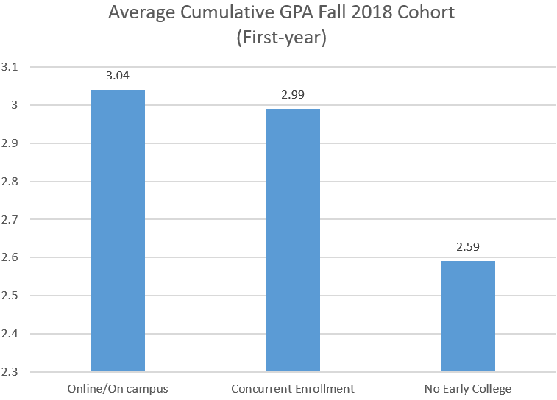
Figure 4 – Link to Text-only description for Average Cumulative GPA Fall 2018 Cohort (First Year) Bar Graph

Data are consistent regardless of whether students took courses online, on campus, or in courses taught by their high school teacher (CE). This data supports the assertion that Maine’s high school teachers, in collaboration with university faculty, are providing a high quality and rigorous curriculum that reflects the outcomes of the online/on campus sections. CE high school teachers work closely with faculty liaison to ensure that courses are comparable to university courses. All UMS campuses are working towards full implementation of the accreditation standards established by the National Alliance of CE Partnerships (NACEP). NACEP is the only national membership-based organization representing concurrent and dual enrollment partnerships (National Alliance of Concurrent Enrollment Partnerships, 2020). NACEP standards are considered to be best practices by the New England Commission of Higher Education (New England Commission of Higher Education, 2016).
The differences in average GPA for UMS EC students of 0.45 and 0.4 are higher than reported in national studies (0.11 and 0.16). According to An and Taylor (2019) “The weight of evidence shows students who participated in dual enrollment generally do better in college than nonparticipants. This finding is robust to different student samples and different statistical models, and it remains even after accounting for baseline differences between those who participated in dual enrollment and those who do not” (p. 116). Baseline differences accounted for in these national studies include factors such as prior academic ability and student’s demographic background.
EC students are more likely to persist during their first year of college. The graph below shows retention rates for students who graduated from high school, matriculated in 2018, and returned to that university the subsequent fall. Males and under-represented minorities benefit most, with improved retention rates of 12% and 14% respectively, when compared to similar peers with no EC courses. Persistence is understudied nationally, but the few studies available confirm that EC participation increases first-year persistence (An & Taylor, 2019).

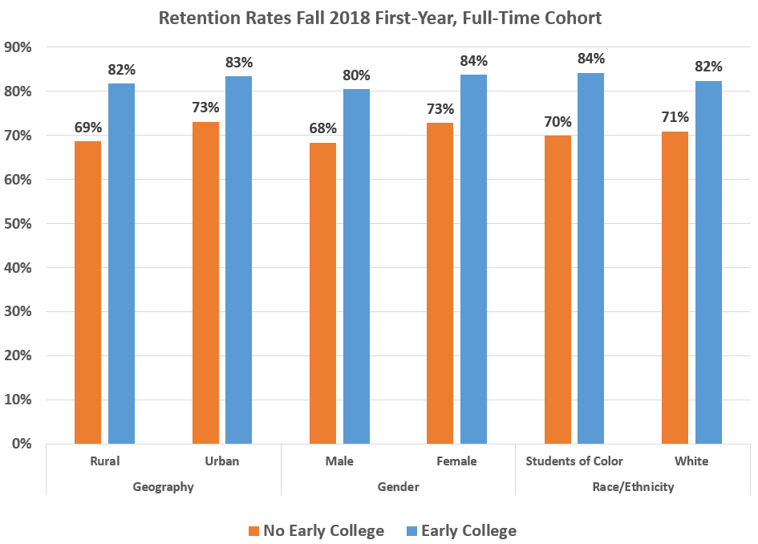
Figure 5 – Link to Text-only Description for Retention Rates Fall 2018 First-Year, Full-Time Cohort bar graph

Degree Completion

Degree completion is the final, and perhaps the most important indicator of EC program success. The minimum increase in percentage points for all UMS EC students (compared to non EC participants) was 12 which is higher than national studies which range from 7 to 8 percentage points (An & Taylor, 2019). Graduation data also show how participation in EC can help to decrease the disparity in college outcomes for students who are from rural areas, males, and students of color. For example, while 43% of students of color with no EC courses graduated in 6 years from a UMS institution, 76% of students of color with EC courses graduated in the same timeframe. Early College benefits all students, but it benefits underrepresented students most. This data further supports the assertion that UMS’ EC programs are helping to close the equity gap in Maine.

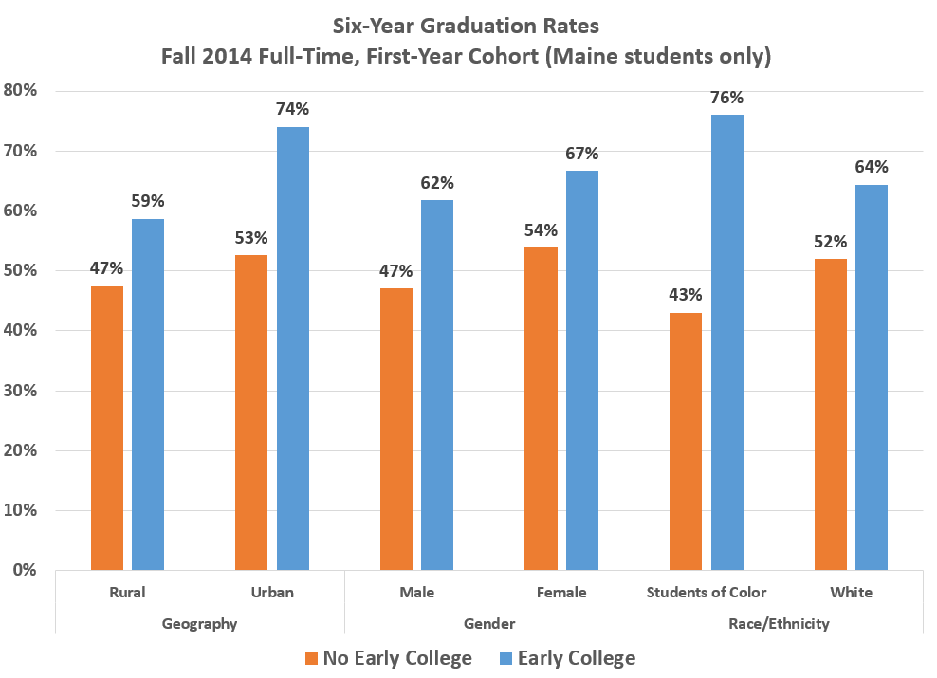
Figure 6 – Link to Text-only description for Six Year Graduation Rate bar graph

Conclusion

The State of Maine has made significant investments in EC programs through the Aspirations program administered by the DOE and through direct funding to the University of Maine System. UMS has also invested in these programs. As stewards of this program, Maine’s Public Universities have collaborated in order to reduce barriers to student access while providing student college advising and support. By collectively waiving over $5.5M in tuition and fees (estimated for FY21), the universities have also demonstrated the commitment to ensuring equitable access for Maine’s public high school students by providing these courses at no or little cost.
The Dual Enrollment Playbook is a compilation of best practices written by prominent researchers and practitioners (Mehl et al., 2020). The authors describe five principles to ensure equity: shared goals that prioritize equity; expand equitable access; support students; provide high quality instruction; and organize teams and develop relationships between high schools and colleges. UMS is working towards and already meeting many of these principles. Equitable access has been expanded and enhanced and will continue as UMS works with MCCS towards implementing a shared application portal. Students in every high school in Maine will have access to EC programs at all 14 public institutions. Student support and college advising has been a priority of all EC teams at all levels from course application process, career exploration pathways, student check ins and frequent communication, collaboration with school counselors, and 1:1 meetings with students. Next steps include career development courses and a greater focus on advising students on college opportunities and academic programs, particularly during their senior year. High quality instruction is provided by UMS faculty through online and on-campus opportunities, as well as in partnership with local high school teachers. Maine’s Public Universities have developed strong relationships with high schools, with the EC program on the forefront of bridging the gap between high schools and universities. Addressing teacher shortages is an unintended, yet beneficial consequence of UMS outreach.
Early College is a sound investment in Maine’s high school students. Student outcomes demonstrate success at every level. EC students perform well in their classes, are more likely to matriculate, have higher GPAs, persist in college, and are more likely to earn a degree. Outcomes are strongest for rural students, males, and students of color. UMS EC data is consistent with peer-reviewed national literature, “With few exceptions, these results are consistent across multiple studies, contexts, and outcomes... the literature suggests dual enrollment has effects not only on proximal outcomes (e.g., high school graduation and college matriculation), but also on distal outcomes (e.g., college completion) as well. This finding is critical and suggests that the effects of dual enrollment do not fade once students enter college”(An & Taylor, 2019, p. 137).
Despite demonstrated success, EC at UMS is facing a critical funding shortage in the Aspirations program. This issue is historic, yet in prior years DOE was able to fund the excess credits to match program growth. The global pandemic has exacerbated this issue, as demand has skyrocketed while the Aspirations budget has been depleted. In January, 2021 Governor Janet Mills unveiled an FY21 supplemental budget proposal that includes an additional $2.5 million for early college spring courses. However, UMS and MCCS project student demand for these courses will continue to exceed funding resources, even after the pandemic. EC programs have removed gatekeeping to provide equitable access to underserved students, yet Maine’s Public Universities will likely be forced to impose additional credit and headcount limits because of the Aspirations budget shortfall.

An, B. P., & Taylor, J. L. (2019). A Review of Empirical Studies on Dual Enrollment: Assessing Educational Outcomes. In M. B. Paulsen & L. W. Perna (Eds.), Higher Education: Handbook of Theory and Research (Vol. 34, pp. 99-151). Switzerland: Springer Nature.
Gravelle, P. (2020). Maine Department of Education: Structure & Governance. Retrieved from https://www.maine.gov/doe/schools/structure
Judd, J. Educate Maine.(2020). Education Indicators for Maine 2020. Retrieved from https://educationindicators.me/#INDICATOR-SUMMARY
Maine Department of Education Data Warehouse: Student Enrollment Data. 2021). Retrieved from Augusta, ME: https://www.maine.gov/doe/sites/maine.gov.doe/files/inline-files/Public%20Funded%20counts%20by%20Student%20Groups%20by%20year%202021.xlsx
Maine Department of Education: Find your School. (2020). Retrieved from https://www.maine.gov/doe/schools/eut/findschool
Mehl, G., Wyner, J., Barnett, E., Fink, J., & Jenkins, D. (2020). The Dual Enrollment Playbook: A Guide to Equitable Acceleration for Students. Washington, DC: The Aspen Institute College Excellence Program.
National Alliance of Concurrent Enrollment Partnerships. (2020). Who We Are.
National Center for Education Statistics. 2017). Selected Statistics From the Public Elementary and Secondary Education Universe: School Year 2015–16. Retrieved from https://nces.ed.gov/pubs2018/2018052/tables/table_04.asp
New England Commission of Higher Education. 2016). Policy on Dual Enrollment Programs. Retrieved from https://www.neche.org/wp-content/uploads/2018/12/Pp128_Policy_on_Dual_Enrollment_Programs.pdf
New England Secondary School Consortium. 2019). Common Data Project Annual Report. Retrieved from https://www.newenglandssc.org/wp-content/uploads/2019/11/2019-NESSC-Common-Data-Report-Final.pdf
Pour, M., & Hubbard, A. (2020). Credits with Purpose. Retrieved from https://www.maine.edu/students/early-college/credits-with-purpose/
Roach, R., Gamez Vargas, J., & David, K. M. (2015). Eliminating barriers to dual enrollment in Oklahoma. New Directions for Community Colleges, Spring(169), 31-38. doi:10.1002/cc.20130
United States Census Bureau. (2019). QuickFacts Maine. Retrieved from https://www.census.gov/quickfacts/ME
Zinth, J. College in High School Alliance.(2019). Funding for Equity: Designing State Dual Enrollment Funding Models to Close Equity Gaps. Retrieved from http://www.nacep.org/resource-center/funding-for-equity/

