High School Student Enrollment in ExplorEC

Create an account
The enrollment process must be initiated by the student. This portal will be used for all students wishing to take classes at any of Maine’s Public Universities. Students must create a new account in the ExplorEC portal the first time applying for courses through this new system (even if a student has previously enrolled in a University course).

You will need your parent/guardian’s email address to submit an application:
Log in at:
https://explorec.maine.edu/
Select “Set up a new account”.

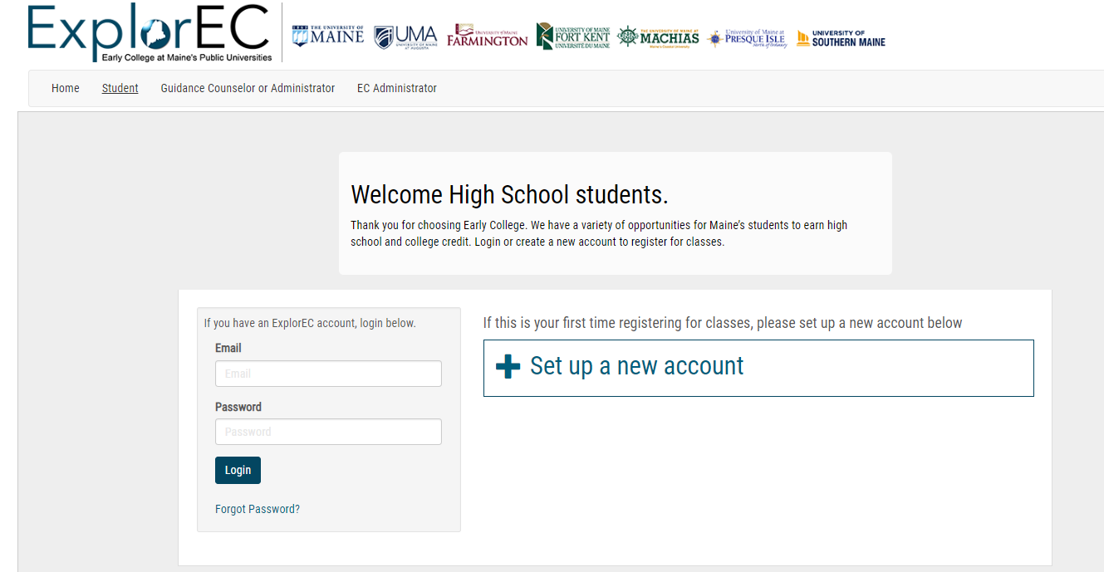

Enter demographic details.
Complete the form by entering your demographic details. You will only have to enter this information once. Once your account is created you can use your email address and password to log into the system. Please enter your information carefully, it will be used to generate a permanent college transcript.

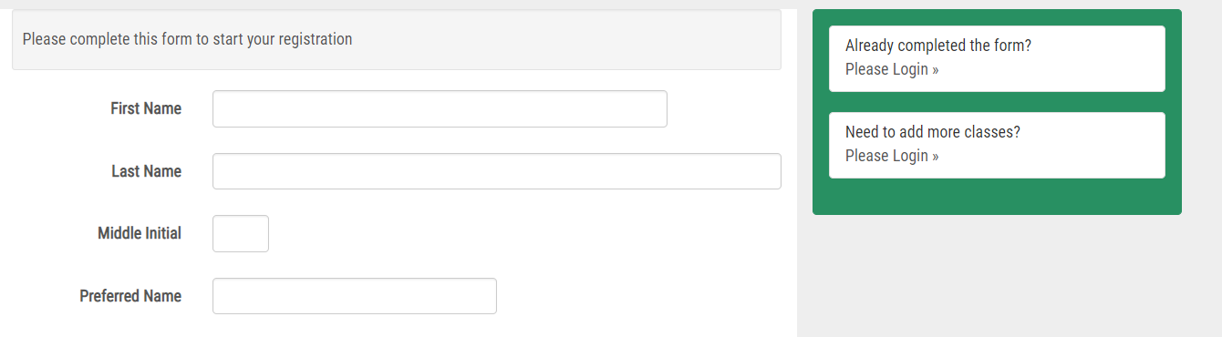

Please note that you must enter a personal email address, not the address assigned by your high school.

Select your high school from the drop down menu. Do not write in the name of your high school unless your school is not listed.
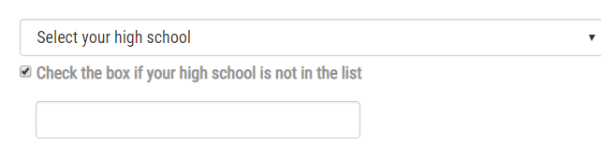

Parent Information
You will need the email address of a parent or guardian and mailing address.
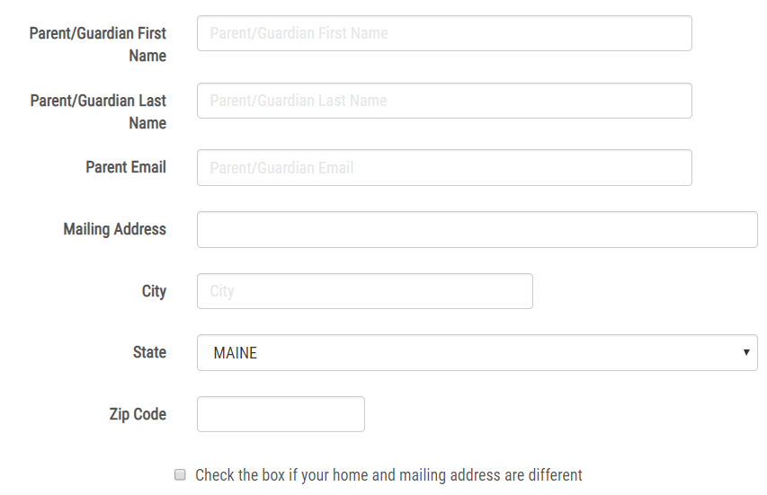

Submit form to continue.

Course Search
Search for the course you would like to enroll in. There are multiple dropdown menus to narrow down your search.
If you are taking a class located at your high school, and taught by your high school teacher (concurrent enrollment), click the tab “EC Class(es) in your High School”. If you are taking a class at a regional technical center, you may not see the classes. In this case, you will need the course number. You can enter the course number in the Search for Class(es) screen.
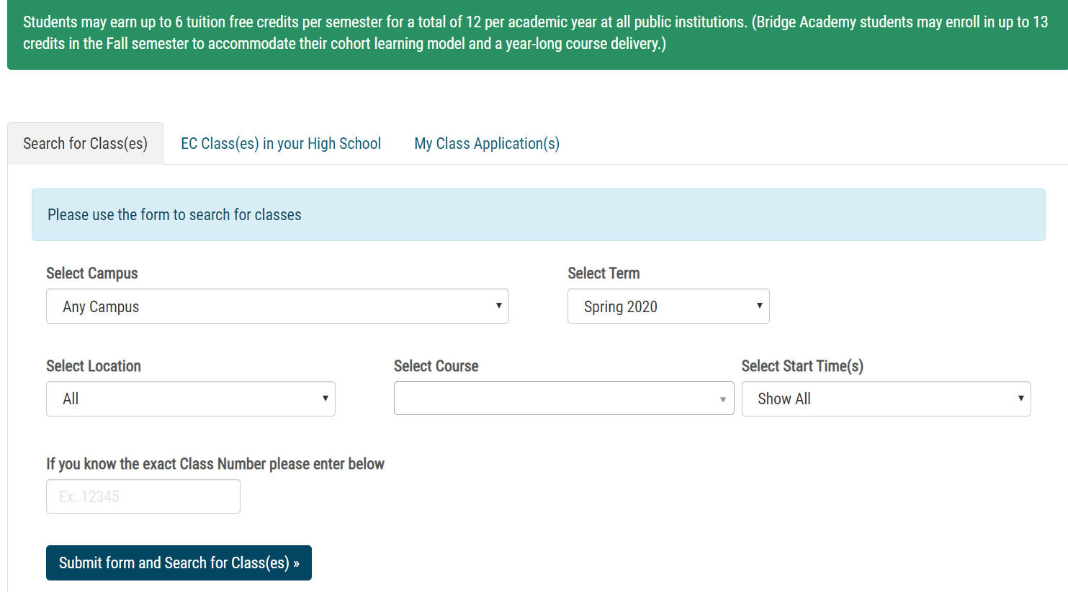
You can also use keywords to search for a particular course.
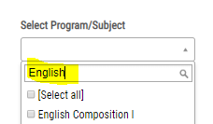
The search will return the results of the class sections available for you register. Please select ALL the classes you wish to apply for and click 'Apply for Classes'.

Prerequisites
Look carefully at the prerequisites listed for courses you are applying for. Prerequisites are requirements that must be met before a student can enroll in a specific course. If you apply for a course, but have not met the prerequisite, your application will be returned to you and you will be asked to select a different course.

Class Applications
The courses you have applied for will appear below.
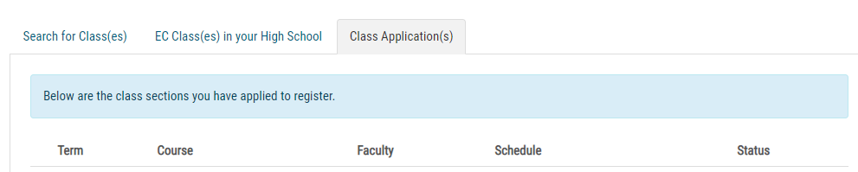
FERPA Release form (Student Consent to Release Information)
You will see the message: Your selected course(s) have been added. If you are done adding classes please review and complete the FERPA release form. Click “review and complete the FERPA” to move to the next step. Read and complete the FERPA form. This form is optional for students 16 and older, but is strongly encouraged.
As an Early College Student, you are included in the University’s FERPA (the Family Educational Rights and Privacy Act) policy. Your education records will be kept confidential and will only be shared with your permission or under provisions of the law. You are encouraged to enter the name of parent(s) or guardian(s) that you wish to grant permission to access your education records (including course grades and payment information). You must also assign a 4 digit PIN (personal identification number) to each person and share that number with them. When your parent or guardian calls the EC Administrator, they will need to provide their PIN for verification purposes.

Student Agreement
Read and sign the Student Agreement. Please note that each University may have some differences in course fees and costs for credits when students enroll in more than 6 classes per semester. Students should visit the website at their University for specific policies and fees.

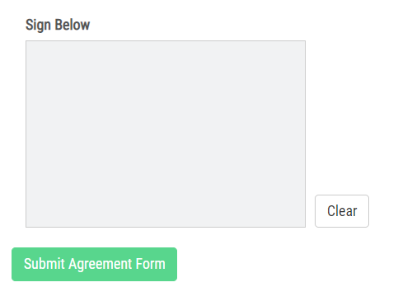

Parent Consent
Request and submit parent/guardian consent to enroll in the course(s) you have applied for. The parent will receive an email and link to sign the consent form. Note if your parent/guardian is with you when you apply, click on Sign Parent Consent Form. When a parent/guardian signs the consent form from the student portal, ExplorEC will send the parent/guardian an email confirmation.

Dashboard
The dashboard will keep track of your progress as each step in the application is completed. If you need to change any of your contact or other information, select “My Profile”.
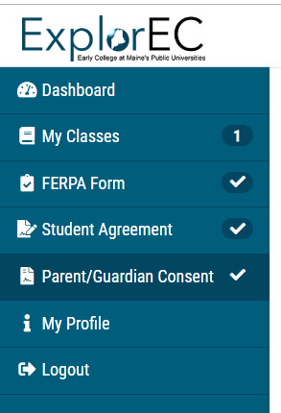

Future Logins
The next time you visit the ExplorEC portal, you can login using your email address and password.

Next Steps
Your high school guidance counselor or administrator will review and approve your application. Then, an Early College Administrator at your campus will process your application and will send you an email confirmation when you have been enrolled for the course or if you need to select a different course. Incomplete applications will not be processed.

Troubleshooting
If you have issues with ExplorEC, please contact the EC Administrator at the campus you are enrolling in.
https://academics.maine.edu/early-college/early-college-contact-us/

