Accessing 1098-T Forms via MaineStreet Student Self-Service

You can now view and print your 1098-T tax forms online via MaineStreet Student Self-Service. Self-Service access to the 1098-T form means you can view and print the form immediately after it is processed and not wait until the paper form arrives in the mail. Additionally, online access to your 1098-T form is an environmentally-friendly and cost-saving alternative.
If you are eligible to receive a 1098-T tax form, it will be available in MaineStreet after it is processed in January. You must grant consent via the MaineStreet Student Center to receive the form online. It only takes a few moments to grant consent.
For general information about the 1098-T tax form, go to University of Maine System 1098-T Information.

Navigation:
Login to MaineStreet Portal and click on Student Self Service > Student Center.
In the Finances section of your MaineStreet Student Center, click on View 1098-T.
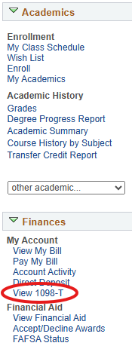
This message below will occur the first time you attempt to view your 1098-T online. Once you have granted consent, this message will no longer show.
Click the “Grant Consent” button.
Note: By granting consent, you are agreeing to accept and receive this and future 1098-T forms electronically and not via the U.S. mail. You will not receive the 1098-T from the University of Maine System in the mail.
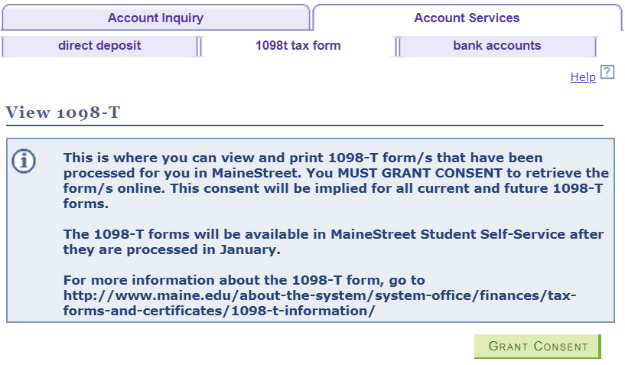
Checking the Yes, I have read the agreement checkbox indicates your agreement to receive this and future 1098-T forms electronically and not via the U.S. mail.
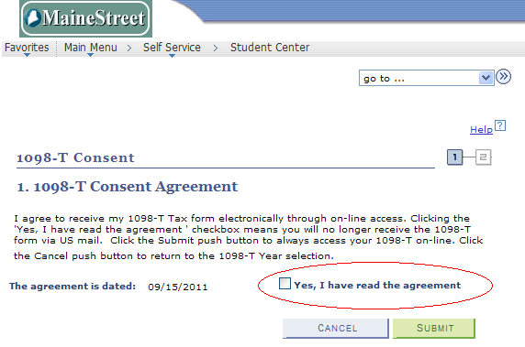
Click the Yes, I have read the agreement option, then click the “Submit” button.
Click the “View 1098-T Selection” button. 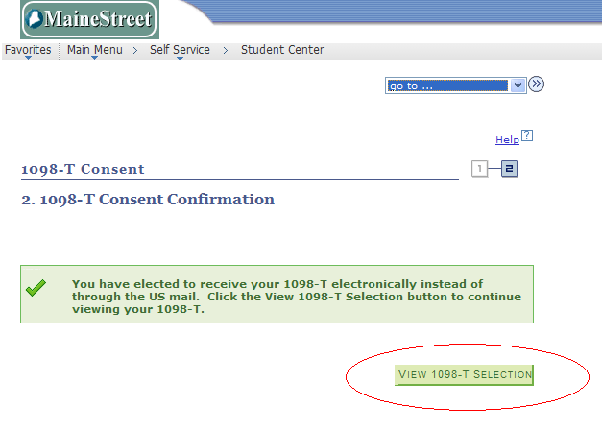
To view your 1098-T for a given tax year, click the link for that year in the Tax Year column.
Note: If you use a pop-up blocker, you must disable it to view your 1098-T. 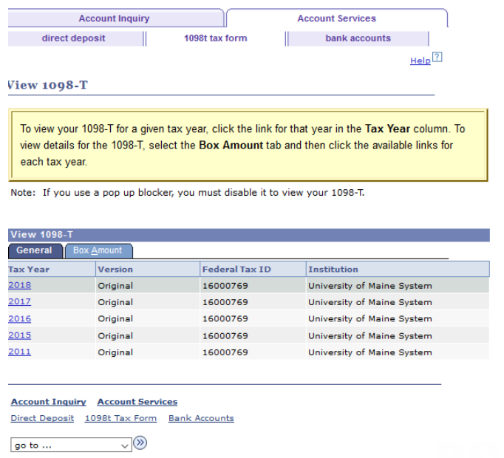
Here is a sample 1098-T that is displayed in a PDF format to print. You can print or save the form for your tax records. 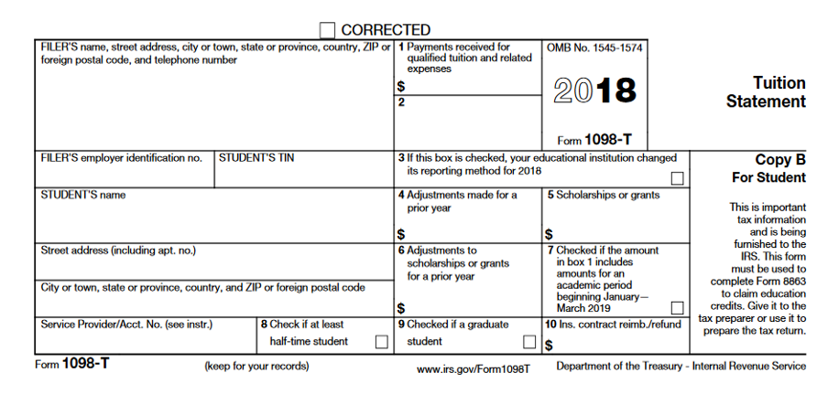
To view box amounts displayed on the 1098-T form and what transactions are factored into each amount, select the “Box Amount” tab. 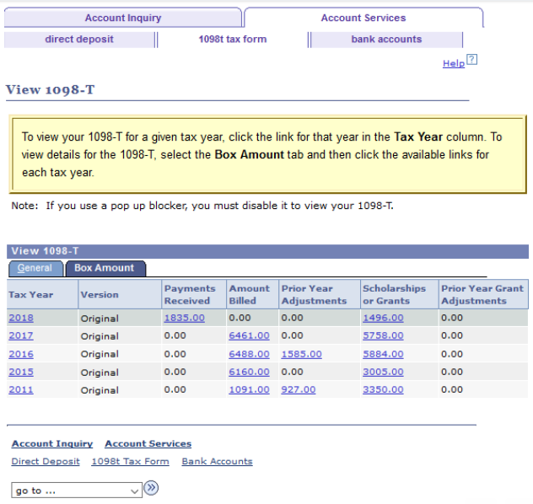
To view 1098-T Box 1 transactions detail, click the link in the Payments Received column.
After reviewing the transactions, select the Return to View 1098-T link. 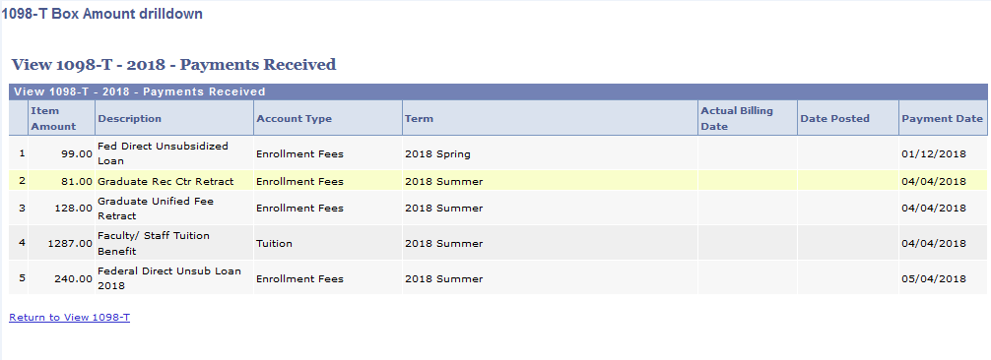
As you did for 1098-T Payments Received (Box 1), select the link in the Prior Year Adjustments column to view the transactions for Box 4, the link in the Scholarships and Grants column to view transactions for Box 5 and the link in the Prior Year Grant Adjustments column to view transactions for Box 6.
Congratulations! You have successfully viewed a 1098-T that can be used when filing your Federal Tax Information.
End of Procedure.

